AYRFP Answers

I.
1. 2. 3. 4.

5. 6.

II.
1.
a. b.
c. d.

2.
a. b. c. d.
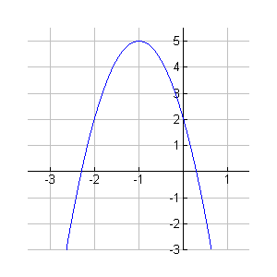
- Graph: at right.
a.

b.
c.

III.
- Solution: , This is where the two lines intersect
- Solution: Infinitely many solutions of the form , since the two lines are really the same line, anything satisfying either equation satisfies both.

IV.
1. 2. 9 3. or 4. a. –16 b. 16
5. 6. 7. a. b. 8. 1

V.
1. 2. 3.
4. 5. 6.

VI.
1. 2. 3.

VII.
1. : Right 2, Down 3 2. : Left 2, Up 1
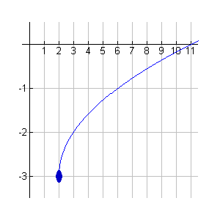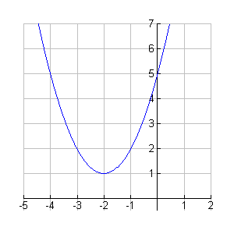
3. : Down 1 4. : Left 1, Down 2
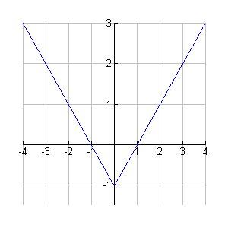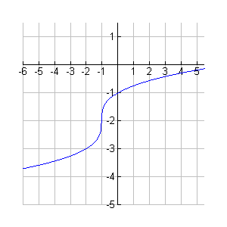

5. : Right 3, Up2 6. : Left 3 -OR- Up 3
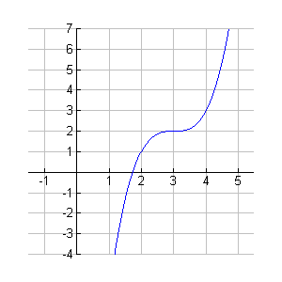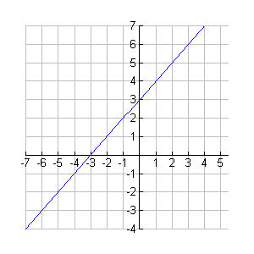

VIII.
1. 2. 3. 4. 5. –3
6. 7. 8. 9.

IX.
- a. Side , Side
b. Side , Side
2.
a.  Angle | b.  Angle
X.
1. 2. 3. 4.

5. 6.

7. 8.

XI.
1. a. b.
2.
3.
4. Even function: y-axis symmetry. Test: . Example:
Odd function: origin symmetry. Test: . Example:
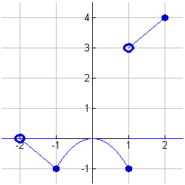
5.

6.

XII.
1.
2.
3.
4. ,
5. , ,
6. Since the coefficients of the squared terms are opposite signs, the conic is a HYPERBOLA
7. D

