Name_____________________________________ Date____________ Per_______

Write a letter to next year’s calculus student. Inform them of your experiences and what they can expect. Answer questions such as, "If only I'd known . . ." or "If I were you, I'd . . ." Be sure to mention which class you’re writing about (AB or BC.) Limit your letter to one typed page. This will be a quiz grade, and will be scored using the rubric below. (Turn this page in as a cover sheet with your letter.)
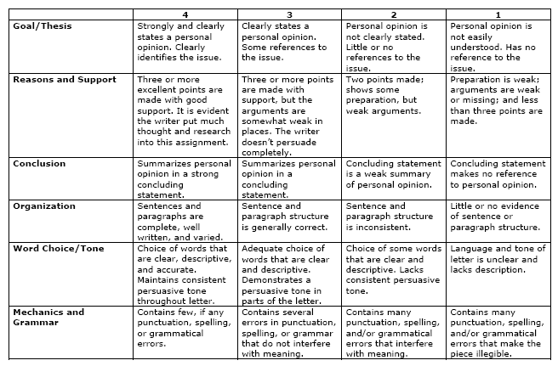
Teacher Comments:

SCORE_______________

