WORKSHEET 4
POLAR

Work the following on notebook paper. You may use your calculator on problems 2-5.

On problems 1-2, sketch a graph, shade the region, and find the area.
- inside and outside
- inside and outside

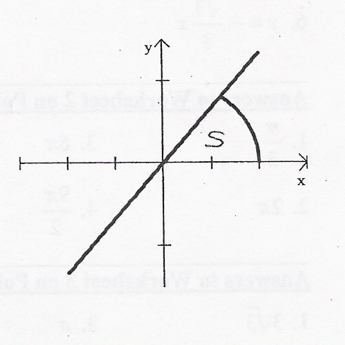
- The figure shows the graphs of the line and the curve C given by . Let S be the region in the first quadrant bounded by the two graphs and the x-axis. The line and the curve intersect at point P.
(a) Find the coordinates of P.
(b) Set up and evaluate and integral expression with respect to x that gives the area of S.
(c) Find a polar equation to represent curve C.
(d) Use the polar equation found in (c) to set up and evaluate an integral expression with respect to the polar angle that gives the area of S.

- A curve is drawn in the xy-plane and is described by the equation in polar coordinates for , where r is measured in meters and is measured in radians.
(a) Find the area bounded by the curve and the y-axis.
(b) Find the angle that corresponds to the point on the curve with y-coordinate -1.
(c) For what values of , is positive? What does this say about r?
(d) Find the value of on the interval that corresponds to the point on the curve with the greatest distance from the origin. What is this greatest distance? Justify your answer.

- (From Calculus, 3rd edition, by Finney, Demana, Waits, Kennedy. P. 561, problem 53)
A region R in the xy-plane is bounded below by the x-axis and above by the polar curve defined by for .
(a) Find the area of R by evaluating an integral in polar coordinates.
(b) The curve resembles an arch of the parabola . Convert the polar equation to rectangular coordinates, and prove that the curves are the same.
(c) Set up an integral in rectangular coordinates that gives the area of R.

