POLAR: DAY 3
POLAR CALCULUS

To find the slope of a tangent line to a polar graph , we can use and and the product rule:
, provided that
Or . . . . create and , then find and

Ex. Find and the slope of the graph of the polar curve at the given value of .
at

Ex. Find the points of horizontal and vertical tangency to the graph of .

POLAR AREA
We are going to look at areas enclosed by polar curves, that’s enclosed, not under as we typically have in these problems. These problems work a little differently in polar coordinates. Here is a sketch of what the area that we’ll be finding in this section looks like.
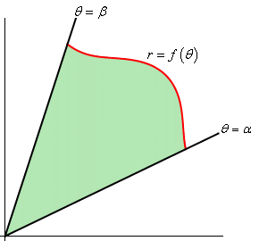
The formula for polar area is different from all previous area formulas, because it is not based on rectangles. Instead, polar area uses and infinite number of sectors to find the area. Remember that a sector is a hunk of a circle, a slice of pizza from the whole pizza.

The area of a sector of a circle is given by , where is in radians. Our area is bounded by the radial lines from to

Ex. Find the area bounded by the graph of

Ex. Find the area of one petal of .

Ex. Find the area of one petal of

Ex. Find the area inside one loop of

Ex. Find the area inside and outside .

Ex. Find the area of the common interior of and .

