POLAR GRAPHS: DAY 1

Put your graphing calculator in POLAR mode and RADIAN mode. Graph the following equations on your calculator, sketch the graphs on this sheet, and answer the questions.
1.
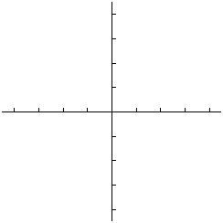

What do you notice about these graphs?

2.
Which graphs go through the pole?
Which ones do not go through the pole?
Which ones have an inner loop?
What causes these things to happen? (Hint: Go to FORMAT and set your calculator to see the Polar Graphing Coordinates when you trace.)

3.
What do you notice about these graphs?

4.
What do you notice about these graphs?

