Limit Algebraic Worksheet
NO CALCULATOR, SHOW ANALYSIS
(Do all work on a separate sheet and transfer answers to this page.)

2.

3.

4.

5.

6.

7.

8.

9.

- If then find the following:
=
=
=
11. [Hint: use Identity for ]

12.

13.

14.

15.

16.

17.

18.

19.

20.
(HINT: is indeterminate form)

21.

22.

23.

24.

25.

26.

27.

28.

29.

30. If , find

31. If , evaluate

32. If , , find

33. Given the following graph below of , find the following:

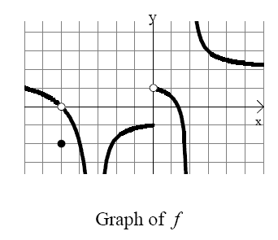
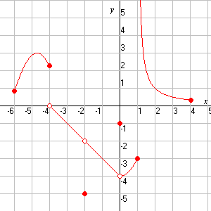
a) b)

c) d)

e) f)

g) h)

Use the figure to answer the following questions:
34. 37.
35. 38.
36. 39.

