NOTES: Derivatives

Calculus grew out of 4 major problems that were perplexing society during the 17th century.
- The tangent line problem
- The velocity and acceleration problem
- The minimum and maximum problem
- The area and accumulation problem

Why were these problems so . . . problematic? Well, because they all deal with quantities that change or deal with variable rates. The algebra of the day was only sufficient to handle stagnant, unchanging, shall I say BORING quantities. A new set of tools was needed to routinely calculate with quantities that were ever changing. In fact, change WAS in the air.

It was the brilliant mathematicians of the day who ultimately came to the rescue. Guys like Pierre de Fermat, Rene Descartes, Christian Huygens, and Isaac Barrow contributed their brilliance, but it wasn’t until two of my heroes, at roughly the same time in different parts of the world, solved the problems. There names were Isaac Newton and Gottfried Wilhelm Leibniz. The debate still exists today (in very small, exclusive circles) over who should get the singular credit for the discovery of calculus.

Let’s take a look at the tangent line problem.

Finding the slope of a line was easy to do. One needed only two points, any two points, on the line. The slope was nothing more than the ratio of the change in y-values over the change in x-values. This value was always the same at every point on the line . . . . boring!

What if we wanted to find the slope of a curve!! What does that mean, exactly? It means that we are interested in the slope of a single line that is tangent to the curve at a specific point. That line is called the tangent line.

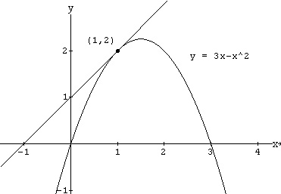
For example, in the graph to the right, we’d like to find the slope of the graph at the point . This would also be the slope of the drawn tangent line.

Why is this so interesting to us? Well, it tells us exactly how fast that graph is changing at that single moment in time, and that instant. It is the instantaneous rate of change of that graph, whose y-values are ALWAYS changing.

Why can’t we do it? Well, it’s because we have only ONE POINT, and the slope equation from algebra requires TWO POINTS!!

OK, then, we’ll choose another point on the curve, but not too far away. We’ll choose another x-value that is, say, h units away from our desired . The new point then becomes . See what I did there? I plugged my new x-value into the function for x.

Now we can calculate the slope or the line containing these two points, known as the secant line, using our algebra formula.

Again, our two points are now and .

This gives us an expression for the slope of the secant line between the two points, but it doesn’t seem anything like a numeric value that is supposed to represent, or even approximate the slope of the tangent line. We can simplify the expression above to make it slightly more “user friendly.”

Here’s the mathmagical secret: we defined h to be the distance between the two x-values we had to use. By use of the limit, we can let h get infinitely small, approaching zero. This has the effect of forcing the two points upon each other. The secant line slope then approaches the tangent line slope!!! Mathematically speaking,

This means that one the graph of , at the point , the graph is rising up one unit for every one unit it moves to the right. It is the instantaneous rate or change at this point. In the very next instant, this rate would be smaller since the tangent line would be less steep just to the right of the point.

We can now find how fast the graph is changing at any other point in a similar fashion . . . . but we can do better than that!

We can actually do it for an arbitrary point, say the point , for an arbitrary function treating the point as a constant, specific point, do all the math similar to what we did above, then end up with an expression involving x, which could then represent ANY point! Here we go.

- Slope of the secant line of between the two points and
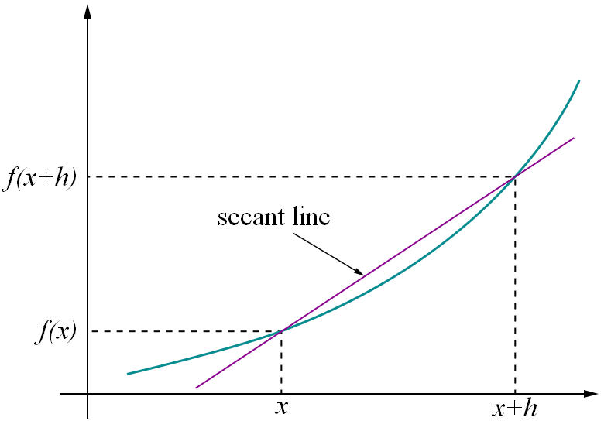

- Slope of the tangent line of at the point
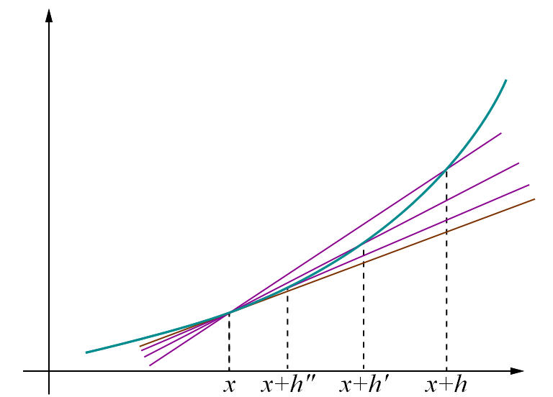
In this picture, you can see the secant lines approaching the tangent line as h gets progressively smaller.

We have a special name for this variable function of x that enables us to find the slope of the tangent line of any function at a specific point: The derivative of , and we denote it by the following mathematical notations: , , , , , , or

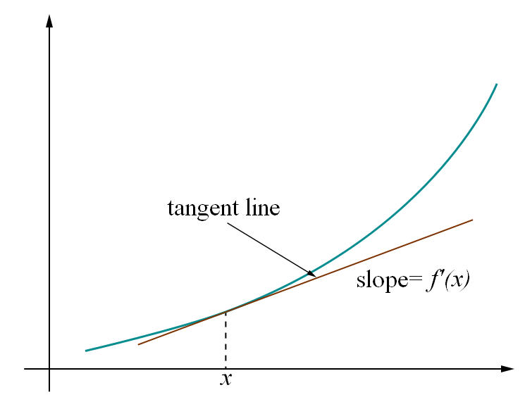

Let’s try out our new toy:

Ex1) Find the derivative of the following function using the limit definition of the derivative.
Solution
So, all we really need to do is to plug this function into the definition of the derivative, (1), and do some algebra. While, admittedly, the algebra will get somewhat unpleasant at times, but it’s just algebra so don’t get excited about the fact that we’re now computing derivatives.

First plug the function into the definition of the derivative.

Be careful and make sure that you properly deal with parenthesis when doing the subtracting.

Now, we know that we can’t just plug in since this will give us a division by zero error. So we are going to have to do some work. In this case that means multiplying everything out and distributing the minus sign through on the second term. Doing this gives,

Notice that every term in the numerator that didn’t have an h in it canceled out and we can now factor an h out of the numerator which will cancel against the h in the denominator. After that we can compute the limit.
So, the derivative is,

Ex2) Use the definition of the derivative as a limit to find the derivative function for

Ex3) Use the definition of the derivative as a limit to find the derivative function for

Ex4) Use the definition of the derivative as a limit to find the derivative function for

In this example we have finally seen a function for which the derivative doesn’t exist at a point. This is a fact of life that we’ve got to be aware of. Derivatives will not always exist. Note as well that this doesn’t say anything about whether or not the derivative exists anywhere else. In fact, the derivative of the absolute value function exists at every point except the one we just looked at, .
This leads to the following definition.

Definition
A function is called differentiable at ifexists. is called differentiable on an interval if the derivative exists for each point in that interval.

Because the previous limit definition of the derivative was a function of h, we must define the derivative at a point in a slightly different fashion, as a function of x.

Definition of the derivative of a function at a point :

In this definition, we still choose another point, , but instead of letting the distance between them go to zero, we let our variable point approach the point we’re interested in .

This gives us a way to calculate differentiability at a point.
Definition
A function is called differentiable at ifexists, that is if

This translates into the fact that, not only do the y-values have to be approaching each other (connected graph) but the slopes have to be approaching each other (smoooooth connection.)

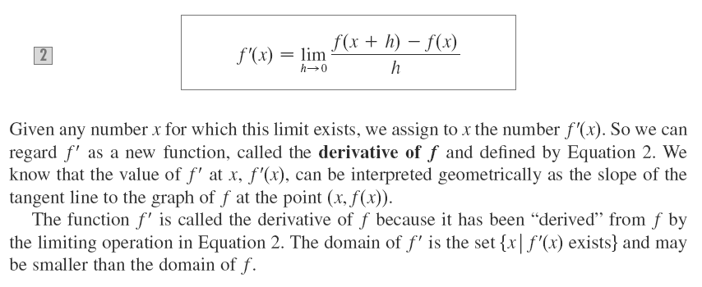
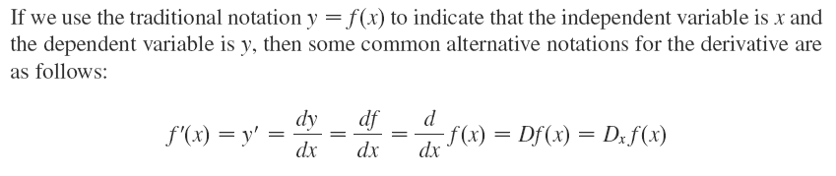
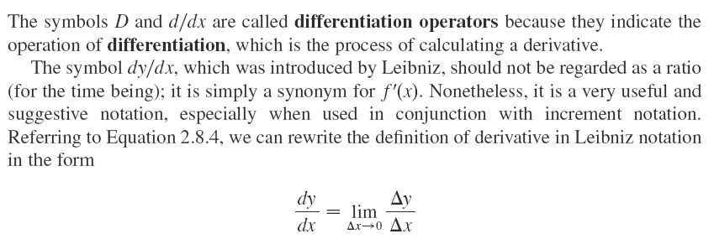
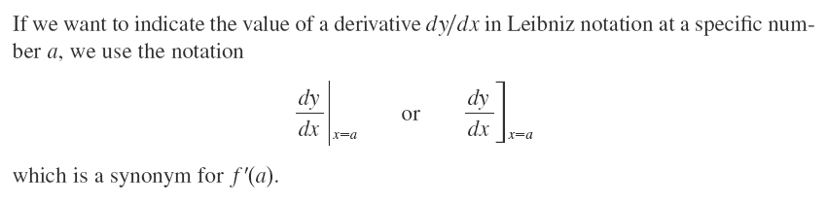

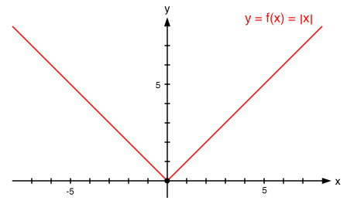
We have seen an example already involving
Here, at , the function is continuous, but NOT differentiable. The slopes from the left are negative one, while the slopes from the right are positive one. Graphically, because we clearly see a SHARP TURN at , we know the function is not differentiable there.

The next theorem shows us a very nice relationship between functions that are continuous and those that are differentiable.

Theorem
If is differentiable at , then is continuous at .

The contrapositive of this is also true:

Theorem
If is NOT continuous at , then is NOT differentiable at .

Ex1) Discuss the Differentiability of at .
Solution:
First notice that .
Now we calculate the left and right-side limits of the slopes:

Since , the function is differentiable at
It’s worth verifying that it IS in fact continuous as well at since
What does all this mean graphically? Let’s sketch it and see.

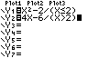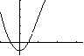
In this case, without the equation, we cannot tell where the parabola actually ends and the line begins.

Ex2) Discuss the Differentiability of at .
Solution:
First notice that still.
Now we calculate the left and right-side limits of the slopes:

Since the right-sided derivative does not exist, the function is NOT differentiable at
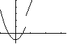
You can clearly see from the graph, that although the slopes from either side APPEAR to be the same on either side of (in fact, they ARE), because the graph is NOT continuous (a jump discontinuity exists), the function is NOT differentiable at . This verifies the theorem:

So far, we have discussed 2 ways whereby a function can not be differentiable. Here are a couple more cases:

Ex3) Discuss the differentiability of at
Solution:

We get the same result from the other side of , so we are approaching infinite slopes (vertical slopes) from either side, therefore, the slope does not exist at and the function is not differentiable at . Here’s what the graph looks like:
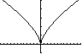
We call this the “bird from Kindergarten” graph. At we have what’s called a “cusp,” which means “sharp point” in no particular language. The sharp turn in the can fall into the family of cusps.
Notice in this example, the derivative doesn’t exist because it’s approaching infinity from both sides, but one could argue also that it is negative (and getting increasingly so) from the left side, while it’s positive (and getting increasingly so) from the left side. Take your pick; the point is, although it IS continuous, it is not differentiable at .

Ex4) Discuss the differentiability of at
Solution:
And

Either way, the limits of the secant slopes do not exist, so is NOT differentiable at . Here’s what the graph looks like:
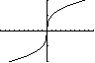
At , you can see that the slope are approaching vertical. That’s because a vertical tangent line exists there. Since a vertical slope is infinite (or undefined) since you cannot ski down it, the derivative (slope) does not exist.
Face it!
Accept it!
Memorize it!

Here’s a summary so far of where a function’s derivative fails to exist at a point (or where it is NOT differentiable.)
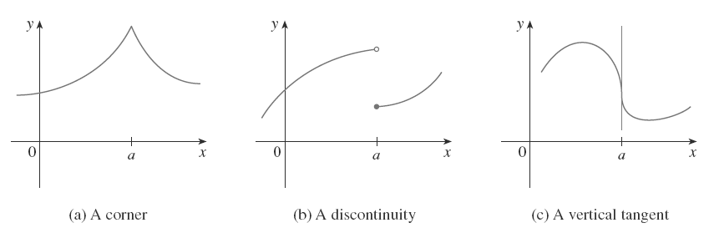

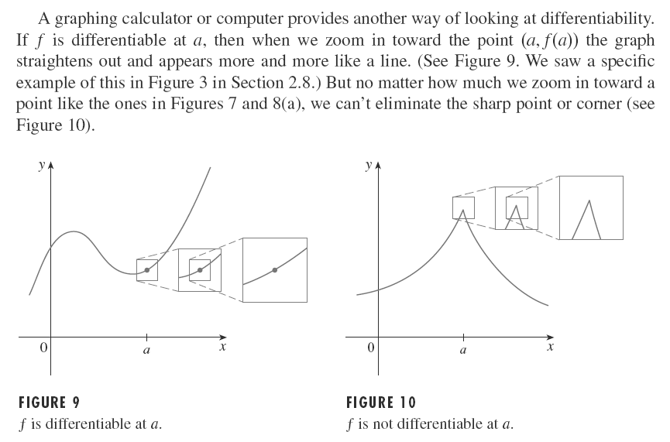

If a function is differentiable at , we can therefore say that it is also locally linear at .
You should try it at for the following functions:
and

Which of them are locally linear (errrrr . . . differentiable) at ?

SKETCHING GRAPHS OF from graphs of
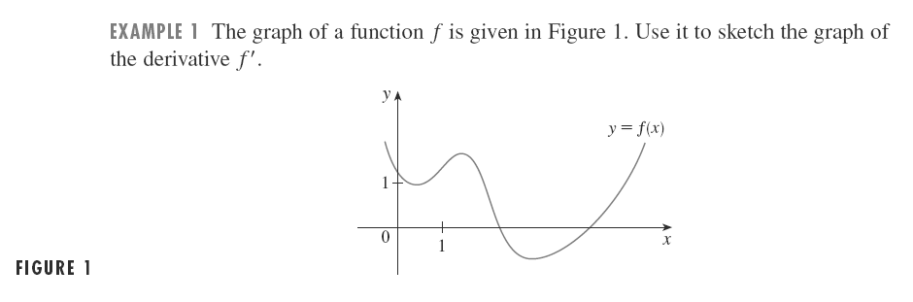
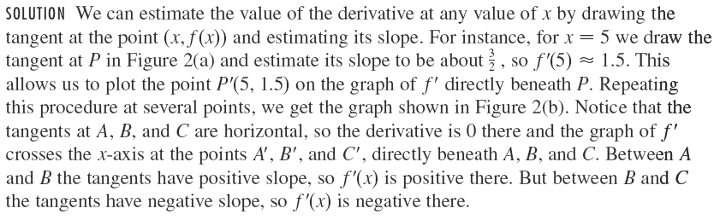
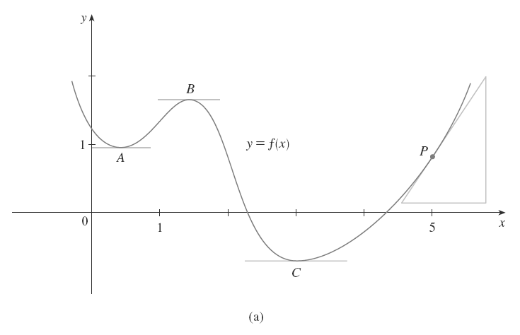
Figure 2

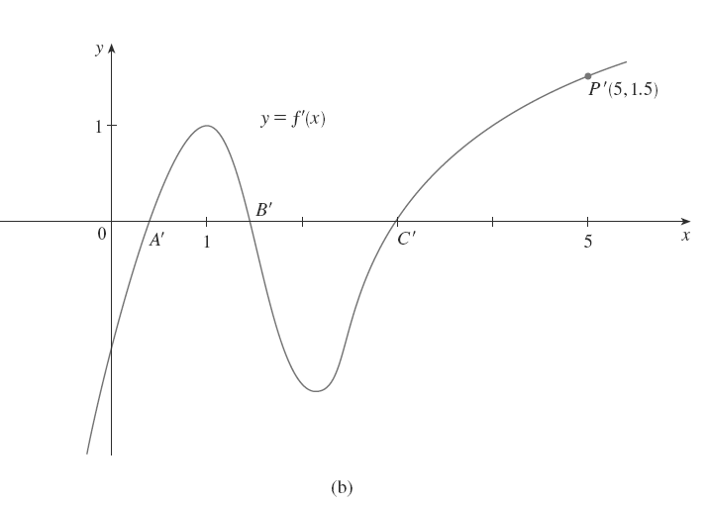
Figure 2

Now try the following exercises:
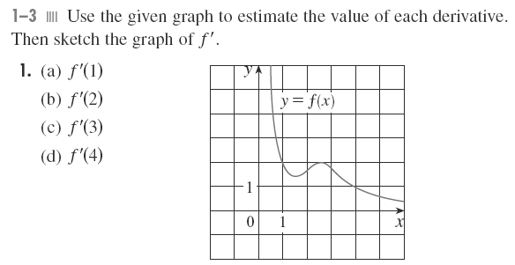
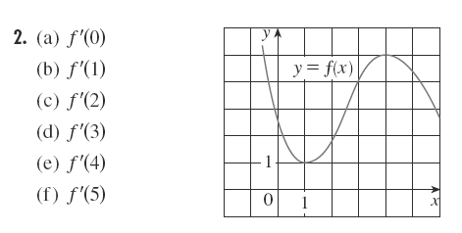
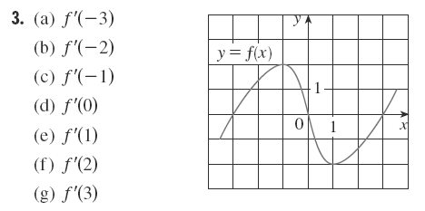

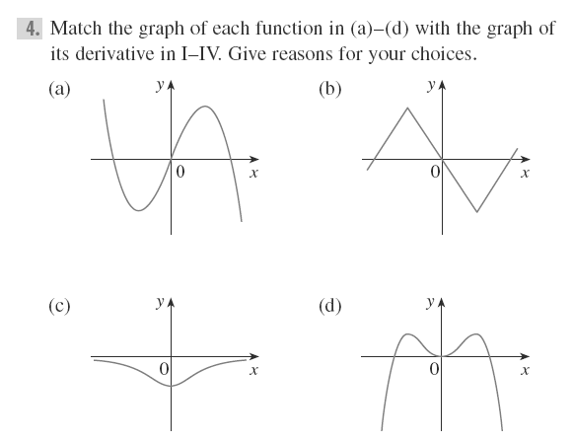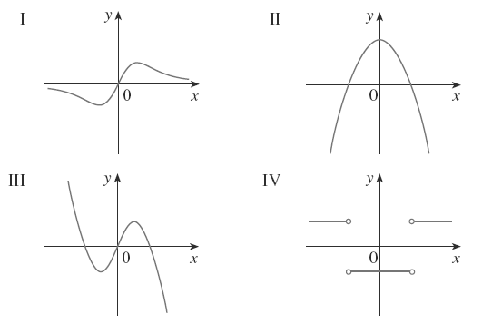
In 5-13, a graph of a function is given. On the same axes, sketch a graph of .
